Date: 28/09/2018

Synopsis

PROJECT TITLE:
“FoodFinder: A restaurant recommender system”

Batch No: 7
Sl. No. | USN | Name | E-mail id | Contact number
01 | 1RN15CS110 | Sunidhi Hegde | sunidhihegde.1rn15cs110@gmail.com | 9035905775
02 | 1RN15CS119 | Varsha Ravindra | varshar.1rn15cs119@gmail.com | 9980400040

Internal Guide Details | : Dr. Shashidhar H R
Designation | :
Contact number | :
E_mail_ID | :

- Objective/ Aim of the project:

The main aim of this project is to design a recommendation system which searches through large volume of dynamically generated information and provides users with accurate and relevant recommendations by incorporating user’s contexts and the possible contextual information of the consumed contents.

- Introduction:

With the rapid development of internet technology, cloud computing and smartphones, the information overload has become a major issue in our life, which makes the users hardly handle a wide variety of important information effectively. On the internet, where the number of choices is overwhelming, there is a need to filter, prioritize and efficiently deliver relevant information in order to alleviate the problem of information overload, which has created a potential problem to many internet users. Recommender systems solve this problem by searching through large volume of dynamically generated information to provide users with personalized content and services
Recommender system was defined as a means of assisting and augmenting the social process of using recommendations of others to make choices when there is no personal knowledge or experience of the alternatives. Approaches for building recommendation systems include content-based filtering and collaborative filtering techniques.
Content-based filtering techniques normally base their predictions on user’s information while ignoring the contributions from other users. Collaborative filtering technique is the most mature and commonly implemented. Collaborative filtering recommends items by identifying other users with similar taste; it uses their opinion to recommend items to the active user. The core of collaborative filtering is to calculate the similarity between users. Thus, increasing exactness for the closeness figuring prompts a more viable and effective suggestion framework.

- Technical details/ flaws about existing system:

In existing systems, as implemented by Swiggy and Zomato, the user is required to specify his preferences beforehand in order to get the restaurant suggestion. Both in Swiggy and Zomato, the suggestions of restaurants are only provided based on the location given by the user.
To a certain extent, earlier researches alleviate the problem of sparsity and cold start to the algorithm. When calculating the user similarity, the above algorithms don’t take user interest into account, and neglect the influence of different rating standards between users on the similarity calculation, which would lead to less accountable result.

- Technical details about the proposed project:

The proposed algorithm for collaborative filtering can be concluded in the following steps:
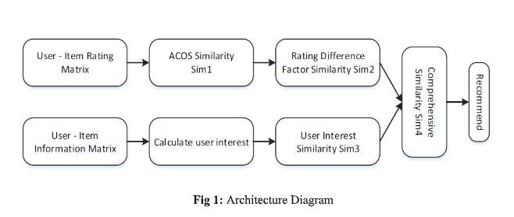
The proposed algorithm steps are as follows:
- Input user-item-score training table, establish a user-item rating matrix.
- Calculate the similarity between the users by using the traditional algorithm to get the user similarity matrix.
- Calculate the difference between users and difference factor, then add the factor to the result of step ii.
- Input the item attributes table, establish a user-item-genre matrix. Then calculate the interest of each user, and further get user similarity.
- Combining the user rating similarity matrix of step iii., and the user interest similarity matrix of step iv., the user comprehensive similarity matrix is obtained by weighted calculations.
- Obtain the user top-N neighbor set according to the user’s comprehensive similarity matrix.
- Calculate the user’s rating forecasting set according to the top-neighbor set.

- Innovativeness & Usefulness:

The two major benefits of using a recommender system is revenue and customer satisfaction. With years of research, experiments and execution, not only is there a less of a learning curve for online customers today. Many different algorithms have also been explored, executed and proven to drive high conversion rate vs. non-personalized product recommendations.
Many a time, customers tend to look at their product recommendation from their last browsing. This is mainly because they think they’ll find better opportunities for good products. This type of customer satisfaction leads to customer retention.

- Requirements specification:

Hardware requirements-
System : Pentium IV 2.4 GHz
Hard disk : 500 GB
RAM : 4 GB

Software Requirements-
Operating System : Windows 7/ higher
Programming language : Python
IDE : Spyder
Database : MongoDB

- Current Status of Development:

Procured the dataset required for the project.

SD/- SD/-
Coordinator HOD
Dept of CSE, RNSIT Dept of CSE, RNSIT

